- Write a MATLAB/Python program to perform image negative transformation on a grayscale image. Display the original and transformed images and explain the effect of the transformation.
PROGRAM:
% Image Negative Transformation on a Grayscale Image

clc;
clear;
close all;

% Read the grayscale image
img = imread('cameraman.tif'); % You can replace with your own image

% Convert to grayscale if the image is RGB
if size(img,3) == 3
img = rgb2gray(img);
end

% Perform Negative Transformation
negative_img = 255 - img;

% Display Original and Negative Images
figure;

subplot(1,2,1);
imshow(img);
title('Original Grayscale Image');

subplot(1,2,2);
imshow(negative_img);
title('Negative Image');

% Display message
disp('Image Negative Transformation Completed Successfully.');
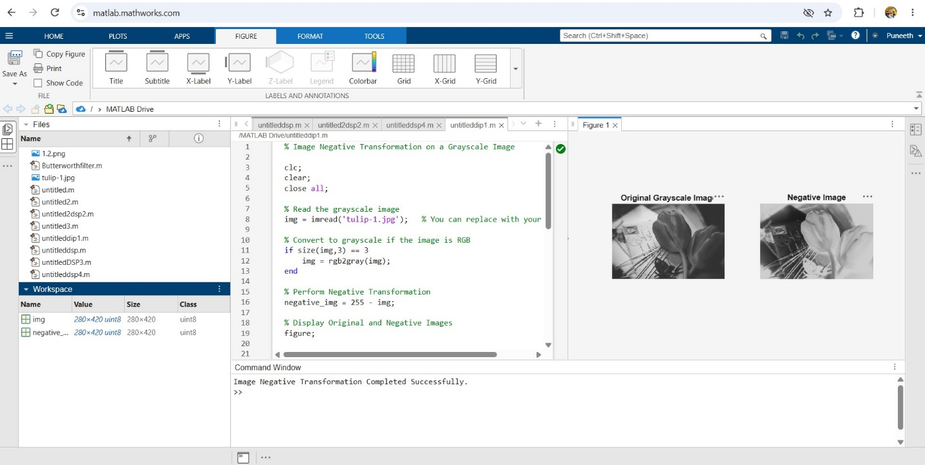

- Develop a program to perform histogram equalization on a low-contrast image. Plot the histograms before and after enhancement and interpret the improvement in image quality.
Program:
% Histogram Equalization on a Low-Contrast Image

clc;
clear;
close all;

% Read the grayscale image
img = imread('cameraman.tif'); % Built-in MATLAB image

% Convert to grayscale if the image is RGB
if size(img,3) == 3
img = rgb2gray(img);
end

% Create a low-contrast version of the image
low_contrast = imadjust(img,[0.3 0.7],[0.4 0.6]);

% Perform Histogram Equalization
equalized_img = histeq(low_contrast);

% Display Images
figure;

subplot(2,2,1);
imshow(low_contrast);
title('Low-Contrast Image');

subplot(2,2,2);
imshow(equalized_img);
title('Histogram Equalized Image');

% Histogram before enhancement
subplot(2,2,3);
imhist(low_contrast);
title('Histogram Before Enhancement');

% Histogram after enhancement
subplot(2,2,4);
imhist(equalized_img);
title('Histogram After Enhancement');

disp('Histogram Equalization Completed Successfully.');
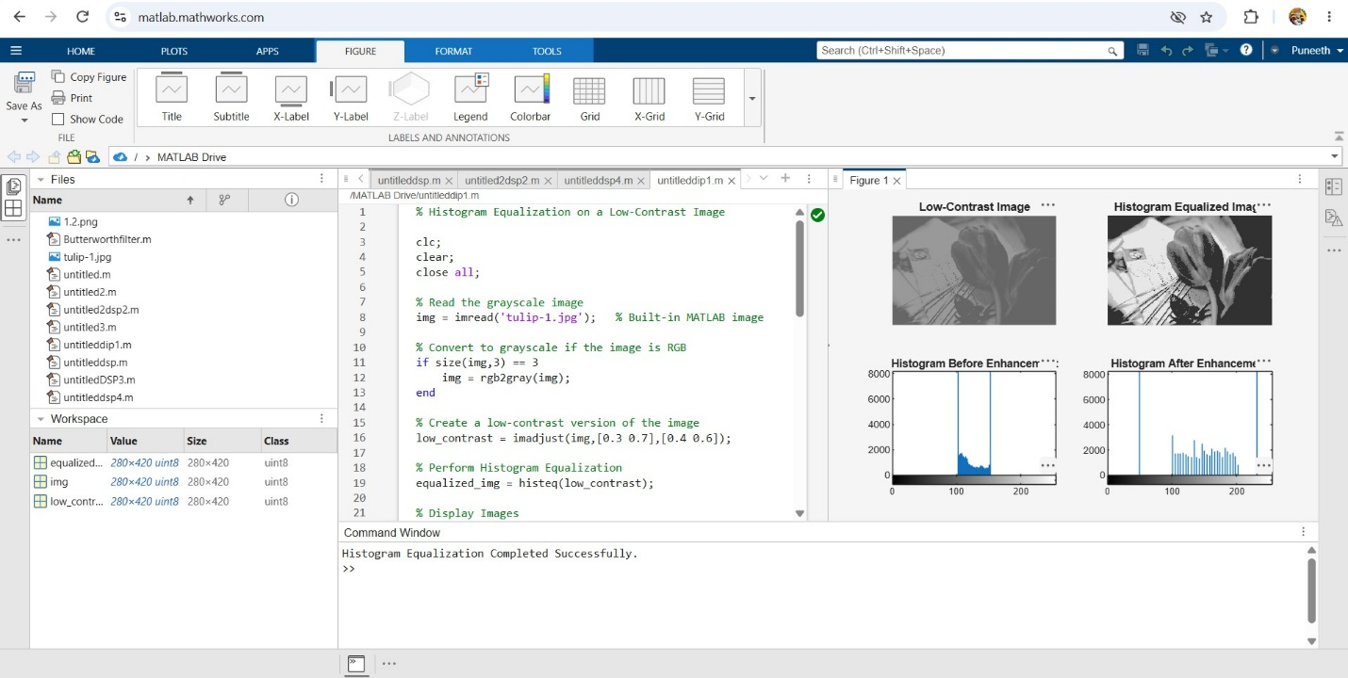

- Write a program to perform contrast stretching using gray-level transformation. Compare the enhanced image with the original image and discuss the changes in contrast.
Program:
% Contrast Stretching using Gray-Level Transformation

clc;
clear;
close all;

% Read the image
img = imread('cameraman.tif'); % Replace with your own image if required

% Convert to grayscale if the image is RGB
if size(img,3) == 3
img = rgb2gray(img);
end

% Convert image to double precision
img = im2double(img);

% Perform Contrast Stretching
stretched_img = imadjust(img, stretchlim(img), []);

% Display Original and Enhanced Images
figure;

subplot(2,2,1);
imshow(img);
title('Original Image');

subplot(2,2,2);
imshow(stretched_img);
title('Contrast Stretched Image');

% Display Histograms
subplot(2,2,3);
imhist(img);
title('Histogram of Original Image');

subplot(2,2,4);
imhist(stretched_img);
title('Histogram after Contrast Stretching');

disp('Contrast Stretching Completed Successfully.');
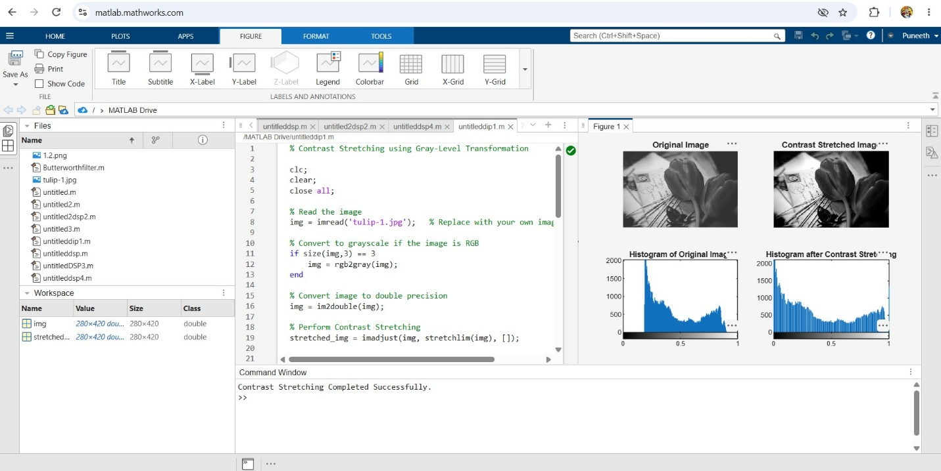

- Develop a MATLAB/Python program to implement a 3 × 3 Mean Filter for image smoothing. Compare the filtered image with the original noisy image and comment on the results.
Program:
% 3x3 Mean Filter for Image Smoothing

clc;
clear;
close all;

% Read the grayscale image
img = imread('cameraman.tif');

% Convert to grayscale if RGB
if size(img,3) == 3
img = rgb2gray(img);
end

% Add salt & pepper noise
noisy_img = imnoise(img,'salt & pepper',0.05);

% Create a 3x3 Mean Filter
mean_filter = fspecial('average',[3 3]);

% Apply Mean Filter
filtered_img = imfilter(noisy_img, mean_filter);

% Display Images
figure;

subplot(1,3,1);
imshow(img);
title('Original Image');

subplot(1,3,2);
imshow(noisy_img);
title('Noisy Image');

subplot(1,3,3);
imshow(filtered_img);
title('Filtered Image (3x3 Mean Filter)');

disp('3x3 Mean Filtering Completed Successfully.');
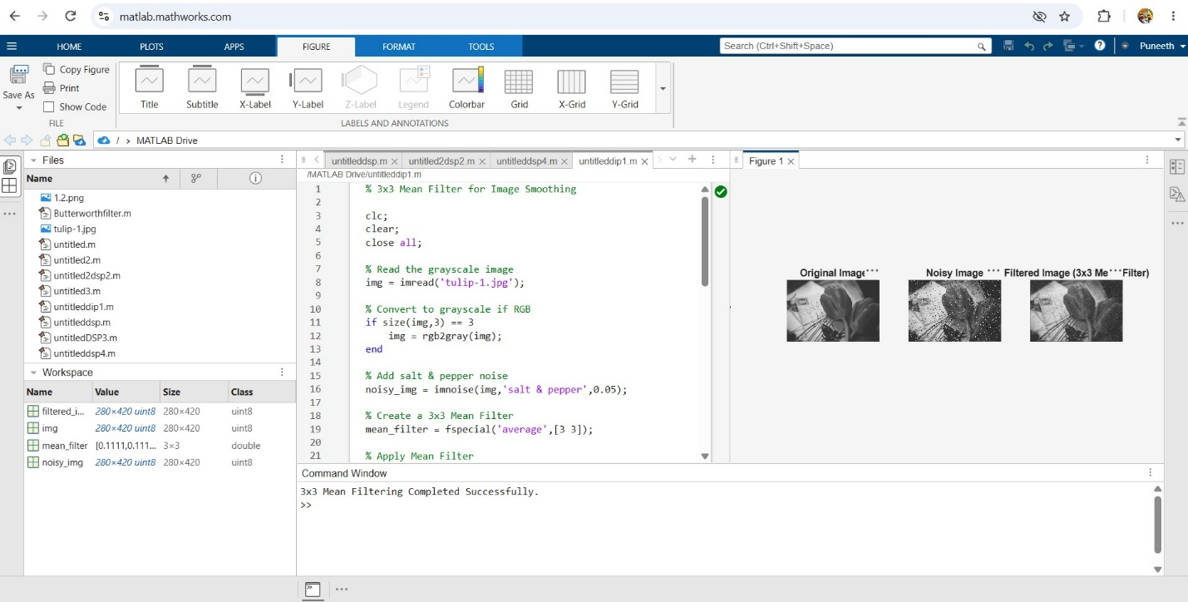

- Implement a Median Filter to remove salt-and-pepper noise from an image. Compare its performance with the Mean Filter and justify which filter is more suitable.
Program:
% Median Filter vs Mean Filter

clc;
clear;
close all;

% Read the grayscale image
img = imread('cameraman.tif');

% Convert to grayscale if the image is RGB
if size(img,3) == 3
img = rgb2gray(img);
end

% Add Salt-and-Pepper Noise
noisy_img = imnoise(img,'salt & pepper',0.05);

% Apply 3x3 Mean Filter
mean_filter = fspecial('average',[3 3]);
mean_img = imfilter(noisy_img, mean_filter);

% Apply 3x3 Median Filter
median_img = medfilt2(noisy_img,[3 3]);

% Display Images
figure;

subplot(2,2,1);
imshow(img);
title('Original Image');

subplot(2,2,2);
imshow(noisy_img);
title('Noisy Image');

subplot(2,2,3);
imshow(mean_img);
title('Mean Filter Output');

subplot(2,2,4);
imshow(median_img);
title('Median Filter Output');

disp('Filtering Completed Successfully.');
